The Physics of Induction Hobs: Efficient Heating Through Electromagnetic Principles

Phạm Hoàng Tuấn Tú, ITCSIU24092
School of Computer Science and Engineering, International University
Physics 3
June 1st, 2025

Introduction
In the era of Industry 4.0, we have been increasingly exposed to a wide range of modern technologies and machinery. These cutting-edge implements have significantly contributed to the enhancement of our lives, augmenting both their qualitative aspects and safety paradigms. Alongside these technological advancements, culinary equipment and tools have also undergone continuous innovation to suit the trends. Modern kitchens are becoming more compact, with cooking utensils designed to be smaller, more efficient, and safer for users. A notable practical application is the induction hob, a device that applied fundamental laws of electromagnetism in its operation.
An induction hob is a cooking device that uses electromagnetic induction to directly cook the food without creating fire. So, how can we have heat without fire? The answer is the science of induction, where strong electric fields can create heat. Induction hobs transfer energy directly to the cookware without heating the hob surface itself, in contrast to gas or conventional electric cooking appliances. Additionally, it is more effective than other cooking techniques. Due to the heat being directly transferred to the base of the pan, it uses less electricity than ordinary electric cooktops. As a consequence, foods can be heated quicker. These advancements of induction hobs also help reduce the carbon footprint compared to gas hobs. This report will explain the fundamental concepts, physics laws involved, basic components, and working principles.

Electromagnetic Principles Involved
This section of the paper will examine the laws of physics that apply to the induction hob.

Faraday’s Law of Electromagnetic Induction
Faraday's Law of Electromagnetic Induction states that an electromotive force (EMF) is induced in a closed loop when a magnetic flux changes. When an alternating current (AC) passes through a flat copper coil (often made of Litz wire) in an induction hob, it creates a time-varying magnetic field that causes an electromagnetic force (EMF) and, consequently, eddy currents in the cookware's metallic base.
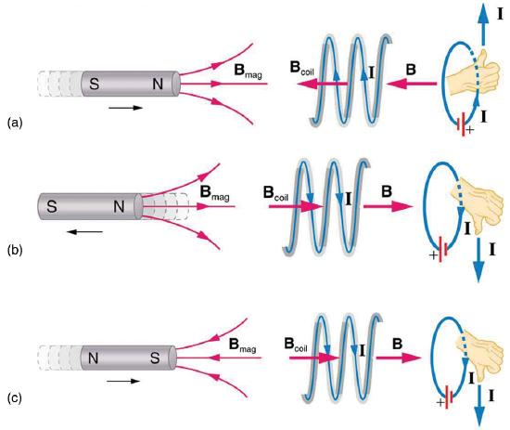
The electromotive force (EMF) is represented by $ε=-N\frac{dΦ}{dt}$, where N is the coil number of turns and Φ is the magnetic flux across the coil. The minus sign indicates that Lenz's law, which states that the induced voltage produces a current I and magnetic field B that oppose the change in flux dΦ, is in effect.

Figure a) When this bar magnet is thrust into the coil, the strength of the magnetic field increases in the coil. The coil's induced current opposes the increase by producing another field that points in the opposite direction of the bar magnet's. This is one aspect of Lenz’s law — induction opposes any change in flux.
The magnetic flux is determined by the coil area A, magnetic field intensity B, and angle θ formed between the vector normal (at 90°) to the coil plane and the magnetic field lines of force: $Φ= B A cos(θ)$

Eddy Currents and Joule Heating

Definition of Eddy Current and Joule Heating
According to Faraday’s Law of Induction, eddy currents are loops of electric current induced within conductors by a changing magnetic flux. These currents flow in closed loops in planes perpendicular to the magnetic field. In the context of an induction hob, eddy currents are produced in the metallic material of the cookware when a time-varying magnetic field passes through the base of the appliance.
Because the pan’s material has nonzero electrical resistance, these eddy currents dissipate in the form of heat due to Joule heating. The power loss is given by the expression $P={I^{2}R}^{}$, where I is the current and R is the resistance of the material, which directly heats the cookware without needing an intermediate heating element.

Application in Induction Hobs
The induced eddy currents circulate in the cookware’s base; due to its finite resistance, these currents produce heat exactly where the pan touches the hob. Consequently, they minimize unwanted eddy currents elsewhere. Any stray metallic object (e.g., foil or aluminum) could also host eddy currents, leading to safety hazards. The hob’s control circuit sensor will prevent activation unless it sees the proper ferromagnetic response. Thus, a paper won't catch fire even if it is placed between cookware and an induction cooktop, which makes them safer for users. In addition, induction hobs can provide significant energy savings, particularly in the form of electricity. Very little energy is lost when heating the glass-ceramic surface of the hob because almost all induced currents are contained within the cookware.

Basic Elements or Components

Induction Surface
Typically, materials like toughened glass or premium ceramic glass are used to make this component. The induction surface can withstand heat and pressure and effectively withstand scratches.
Induction Coil
This is an essential component positioned directly beneath the glass surface in each cooking zone that produces heat. Additionally, it ensures stability, durability, and safety when using an induction cooker.
Temperature Sensor
Usually used to maintain the temperature for the IGBT power module, this sensor is mounted on the induction coil and measures the temperature on the glass surface. Additionally, it could help prevent unwanted safety hazards.
IGBT (Insulated Gate Bipolar Transistor)
An electronic switch that controls the power supply, converts, and quickly turns it on and off.
Power Inverter Circuit
Converts mains AC to high-frequency AC (20-100 kHz).
Cooling Fan
Responsible for cooling and reducing the heat on top of the induction hob (especially the glass surface), as well as other internal components.
Control Panel
This component usually consists of a touch screen display that offers an intuitive visual interface. It enables users to regulate and change the induction cooker's heat level.

Working Principle
When the device is activated, an alternating current (AC) flows through the coil beneath the cooking surface, and a compatible ferromagnetic pot, such as one made of cast iron or certain stainless steels, is placed on the hob. This current creates a high-frequency, time-varying magnetic field that permeates the bottom of the cookware. By Faraday’s Law of Electromagnetic Induction, this changing field induces circulating currents, which are called eddy currents, within the conductive material of the pot. Since the pot has inherent resistance, these currents dissipate in the form of heat due to Joule heating, as mentioned. As a result, heat is generated at the bottom of the cookware and then conduction-transferred to the food. Notably, only a suitable pan can be used for this device; if any is not detected, the induction hob will not operate.

Conclusion
In conclusion, the induction hob is a modern, compact, safe appliance in the kitchen designed by applying the basic principles of electromagnetic fields. It operates based on the principles of Faraday’s Law of Electromagnetic Induction, Lenz’s Law, and the phenomena of eddy currents and Joule heating. These laws ensure that heat is generated directly within the cookware, which improves cooking times, reduces energy waste, and increases safety. By understanding the working principles and basic laws of physics applied in this device, we have gained a deeper insight into how advanced electronic devices work.

References
Science in School. (2022, December 15). Faraday’s law of induction: from classroom to kitchen – Science in School. https://www.scienceinschool.org/article/2021/faradays-law-induction-classroom-kitchen/
Ole Witt-Hansen. (2017). The physics of induction stoves.
http://www.olewitthansen.dk/Physics/The_physics_of_induction_stoves.pdf
Kitchens, S. (2024, July 30). Induction hobs: how they work and what pans to use. Sustainable Kitchens. https://www.sustainablekitchens.co.uk/journal/induction-hobs/
Baguley, R., & McDonald, C. (2015, January 12). Appliance Science: The hot physics of induction cooktops. CNET. https://www.cnet.com/home/kitchen-and-household/appliance-science-the-hot-physics-of-induction-cooktops/
Admin. (2022, May 15). What are Eddy Currents? BYJUS. https://byjus.com/physics/what-are-eddy-currents/
Mytour. (2024, November 6). Structure and operation principles of induction cookers. Công Ty Cổ Phần Du Lịch VIỆT NAM VNTRAVEL. https://mytour.vn/en/blog/bai-viet/structure-and-operation-principles-of-induction-cookers.html

